**Barbara Kendall**  
**CS 330 Milestone One**

I chose the following 2D image with a collection of everyday objects arranged on a wooden floor against a neutral wall. Featured in the scene are: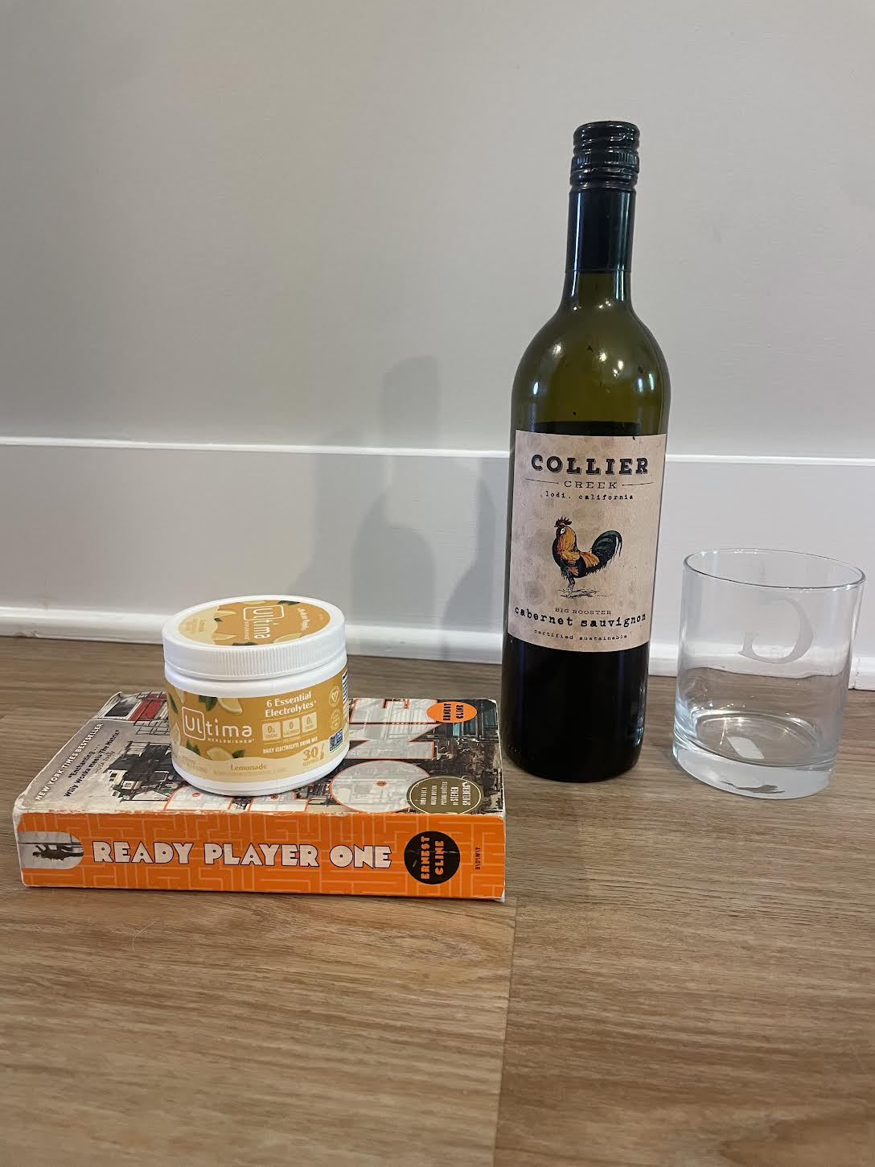

* A **wine bottle**
* A **glass tumbler**
* A **canister** of electrolyte powder
* A **book**

These items are arranged in a simple yet visually engaging way, with different shapes that would be ideal for 3D modeling.

I have chosen to replicate the following four objects from the image:

1. **Wine Bottle** – This is an ideal object because it has cylindrical and tapered shapes.
2. **Glass Tumbler** – Its clear structure and symmetry make it a straightforward yet elegant model to render with lighting effects.
3. **Electrolyte Canister** – It has a squat cylindrical form with distinct label and lid elements.
4. **Book** – Rectangular and flat, the book will serve as the base object to add visual grounding to the scene.

These objects are a mix of complex and simple shapes. They have diverse geometric forms and will allow me to explore textures, lighting, and shadows in OpenGL.

To construct these objects, I will use the following basic 3D shapes:

* **Cylinder**: For the wine bottle’s body, the glass tumbler, and the canister
* **Tapered Cylinder**: For the wine bottle’s neck
* **Box**: For the book
* **Plane**: To represent the wooden floor or base surface

At least one object—the **wine bottle**—is made of multiple shapes: a **cylinder** for the body and a **tapered cylinder** for the neck.

These choices allow for realistic modeling of textures (glass, paper, plastic), transparency (for the tumbler), and reflectivity (the wine bottle). The scene is achievable with my current OpenGL skills and provides opportunities to grow through challenges like applying textures and implementing lighting effects.

The scene is a practical and creative selection that balances visual appeal with achievable modeling goals. The combination of basic 3D shapes and everyday objects will demonstrate fundamental OpenGL rendering capabilities while setting the stage for enhancements in the final project.